**Flasher led circuit**

Adnan Sardi

**Objective**

The goal of the experience is to create a flasher led circuit using an NE555 integrated circuit. A flasher led circuit is a circuit that generates flashes in a certain period of time with the help of a led.

**Theoretical basics**

The flasher led circuit is based on the operation of the integrated NE555, which has various uses in electronic applications for the various configurations that it can take. The main configurations are the astable, monostable and bistable device. For the circuit that we are going to study, we will use an astable configuration, that is, it does not have a stable configuration, so as soon as it is fed it passes from a high logical signal to a low logical signal with a certain time period, period determined by the values of the condenser components and resistors. The diagram of the flasher led circuit is shown below.

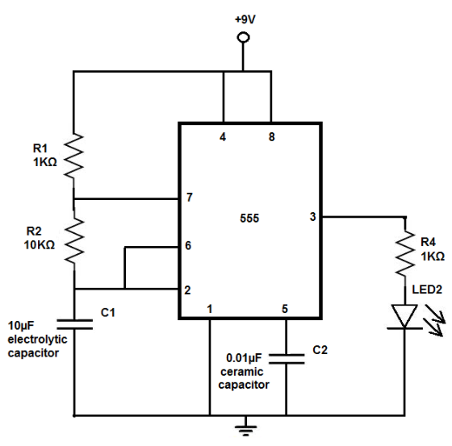

[Fig. 1]

Before describing the behavior of the circuit in its phases we give a brief description of the integrated NE555.

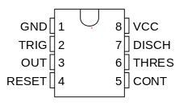

[Fig. 2]

The pin:

1. GND, is the grounding link.
2. TRIG, is the trigger signal which varies in its behavior according to the voltage with which it is powered.
3. OUT, is the output of the integrated.
4. RESET, generates a reset pulse in the built-in memory.
5. CONT, is the control voltage that if not used as in our case is connected to it a capacitor to avoid malfunctions.
6. THR, is the threshold level at which the signal interval ends.
7. DIS, has the task of unloading the capacitor and then starting a new cycle.
8. +V, the pin with which the voltage generator is connected.

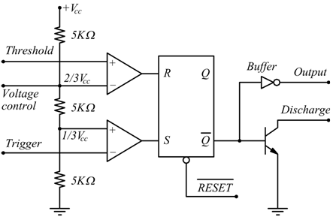

[Fig. 3]

It consists of a voltage splitter composed of three resistors placed in series with a value of 5 KΩ, that switch the voltage value on the inverted input of the first operational amplifier configured as voltage comparator and both of the non invertent input of the second operational amplifier also used as a voltage comparator.

At the exit of our comparators, we find a flip-flop that works like a memory device.

With S we indicate the SET that provides the digital signal 1 while R indicates the RESET that is sets the memory of the flip-flop on the 0 signal, Q is the output that has in memory the flip-flop that we will not use, while Ǭ indicating the inverted Q output. Below is the truth table of the flip-flop.

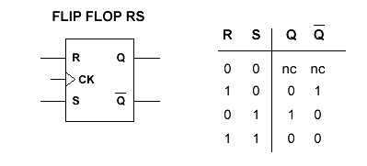

[Fig. 4]

On the flip-flop output we have a logical NOT door that inverts the Ǭ signal and then bring it to the output (pin 3), also we have a transistor connected to the ground called download transistor which serves to download the RC network of our flasher led. Introduced the components with which it is composed the NE555 we can give a description of our circuit.

Initially the voltage at the heads of pin 2 and pin 6 is 0 and the capacitor is discharged, then triggers the comparator at a high logical signal finally getting a flip-flop output at zero and the transistor operates as an open switch letting the capacitor charge.

The voltage at the ends of 2 and 6 reaches $\frac{1}{3}$ V and the trigger comparator switches the flip-flop to S=0 and going to see the [fig.4], we know nothing changes so the capacitor keeps charging. We now have that in the node between pin 2 and pin 6 the voltage continues to charge up to $\frac{2}{3}$ V the comparator of threshold snaps passing to 1 and then sends a reset to the flip-flop that generates output via the inverter a low output and activates the transistor which discharges the capacitor via R₂ .

By discharging over time, the voltage across 2-6 reaches a lower value than $\frac{1}{3}$ V, triggering the trigger comparator and thus opening the transistor which allows the capacitor to charge. This procedure is repeated for the entire duration with which the circuit is powered, generating a periodic switching of the output signal.

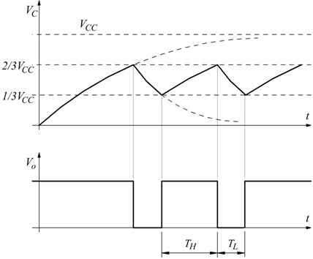

[Fig. 5]

In conclusion we have that the potential difference across the capacitor oscillates between $\frac{1}{3}$ V and $\frac{2}{3}$ V while the output between 0 and V.

Now let’s determine the times with which the capacitor is charged and discharged. During the phase in which the capacitor is charged it assumes an initial value of $\frac{1}{3}$ V and a final value of V thus obtaining:

$V(t)= V_{in}-(V_{in}-\frac{V_{in}}{3})e^{-t/(R_{1}+R_{2})C}$ [1]

Represents the equation that describes the behavior of voltage as a function of time during charging. Knowing that t= that is the time period of the output signal at the high logical value, I get:

$T_{1}=(R_{1}+R_{2})C\ln{2}$ [2]

While for the discharge phase the equation describing the voltage in time is given by the following relation:

$V(t)=\frac{{2V}_{in}}{3}e^{-t/R_{2}C}$ [3]

Finally obtaining a period of time on the low logical signal (T)

$T_{0}=R_{2}C\ln{2}$ [4]

These times we have obtained, are the times with which our LED diode flashes.

**Instrumental description**

For the execution of the experience we used various electronic components listed below:

* NE555 integrated circuit described above;
* Resistors with various values (10 KΩ and 100 KΩ);
* Red LED;
* Ceramic capacitor 104 (100 nf);
* Electrolytic capacitor (470 uf);
* Breadboard;
* Wire jumper;
* Chronometer;
* Power supply battery (9 V);

**Description of experimental procedure**

The experimental procedure for building our apparatus was not complicated.

Before inserting the components on the breadboard it is useful to check the values of the inserted components to avoid burning circuit elements or insert capacitors (C1 [Fig. 1]) too little capacitive, it was also decided to perform three sets of measurements to verify the relationships [2] and [4] by changing the values of resistors and capacitor.

The electrical circuit diagram was reproduced on the tinker cad program ([Fig.6]).

An oscillator connected to the integrated output was added to verify the periods of the low and high logical signals.

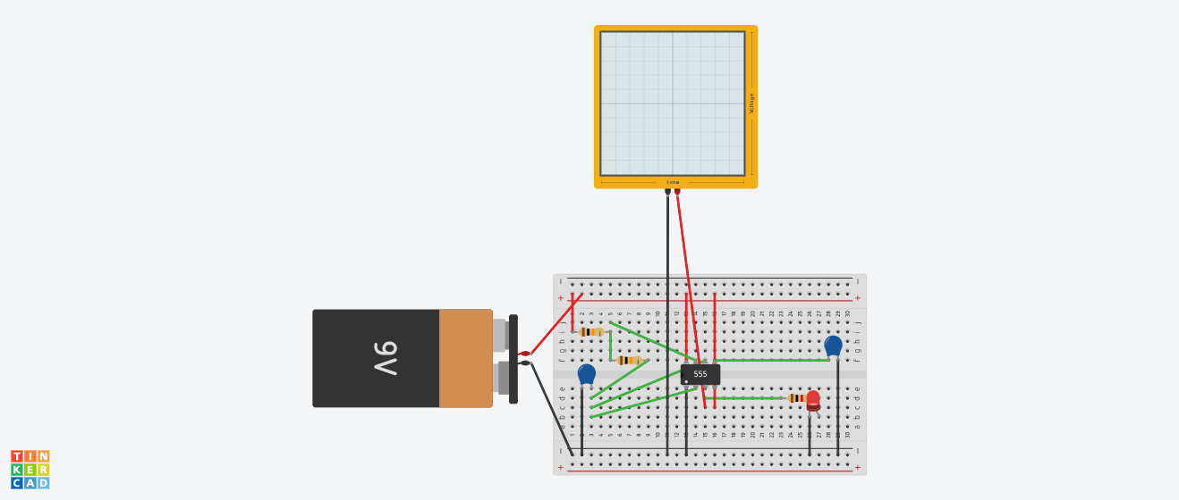

[Fig. 6]

Below we list the various steps in chronological order for assembly:

1. Insert the NE555 integrated into the breadboard and connect pins 1 and 8 to the ground and power supply respectively.
2. Connect pin 4 (reset) also to the power supply and pin 5 to the ground via a ceramic capacitor (104).
3. Insert resistors R1, R2 and electrolytic capacitor C1 in series (FIG.1)
4. Connect an R1 terminal to the power supply.
5. Connect pin 7 (discharge) to the node between R1 and R2 via jumper wire.
6. Connect pins 2 and 6 (trigger and threshold) to the node between R2 and C1 always via jumper wire.
7. Then connect the other C1 clamp to the ground.
8. Insert a resistance of 1KΩ and a led with the clamp of the anode in series with the resistance.
9. Finally connect the LED cathode to the ground and power the circuit with a 9V battery.

Below is the video for the display of the circuit in operation:

[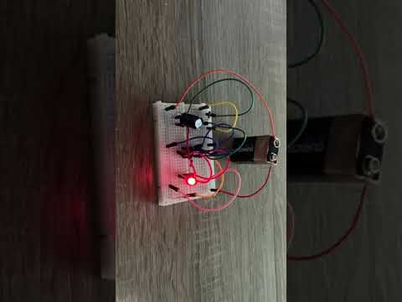](https://www.youtube.com/embed/hav69HEJAaI?feature=oembed)

[Video 1]

**Data presentation and analysis**

Once the circuit was installed we actually checked the relationship [2] and [4] producing 3 sets of measurements. Unfortunately, it was not possible to generate more sets because the electronic components in our possession were limited.

In the first set we used two 10KΩ resistors and a 470uf capacitors thus obtaining as time on the high logical value of:

$$T_{1}=(R_{1}+R_{2})C\ln{2=6,52 s}$$

While on the low logical value of:

$$T_{0}=R_{2}C\ln{2} = 3,26 s$$

These values are the theoretical results that we expect to find. Below is the table of times that have been measured using a stopwatch.



[Tab. 1]

The results found are also confirmed by the oscilloscope that we insert in (Fig.6). operating it we find the following visualization:

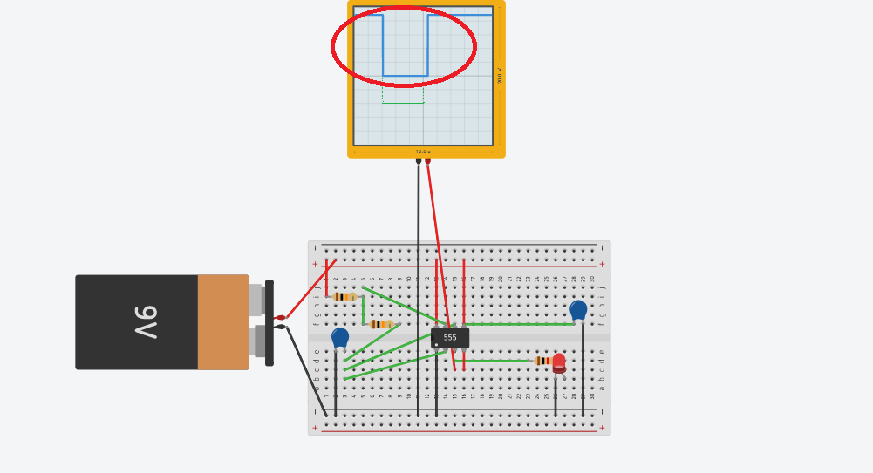

[Fig. 8]

Circled red is the T, which by theory we have derived a value of 3.26 seconds. The oscillator was set with a second per division so always according to the theory we should a low logic signal along three squares plus an “added” of 0.26 seconds. From the picture above we note that the period actually lasts 3 squares with the help of a green line that is nothing more than a translation down plus another shorter period of time less than half of a square which should represent the added 0,26 seconds. The T could not be determined by oscilloscope because the application had a delay that made it impossible to visualize the entire period.

Obviously the duty-cycle of our circuit will never be 50%, this in addition to testing it experimentally you can immediately notice it from the reports [2] and [4] because in one case we have a term R2 that multiplies C while in the other we have a term given by the sum of resistances. One solution is to annihilate the R1. This is possible by inserting a diode in parallel with R1 thus obtaining a duty-cycle of 50%. The verification was confirmed with the following results:



[Tab. 2]

**Conclusions**

The circuit in addition to effectively flashing the LED through the charge and discharge of the capacitor [Video 1] reflects the theoretical values with the experimental ones regarding the period. Obviously the period found experimentally is higher than the theoretical one, this is due to a systematic error that the experimenter has when activating the stopwatch for time measurements. For much more precise measurements a timer can be installed that clicks every time the LED turns on or off then also connecting it to the output of the timer 555. The flasher LED circuit that we mounted is as simple as possible because we used few components, for more complicated and at the same time more interesting circuits it is necessary to use more components and know how to connect them to each other always based on the use of the timer 555 in astable configuration. In appendix comes left another small circuit always flasher LED but using two integrated and four led.

**Appendix**

LED flasher circuit diagram “2”:

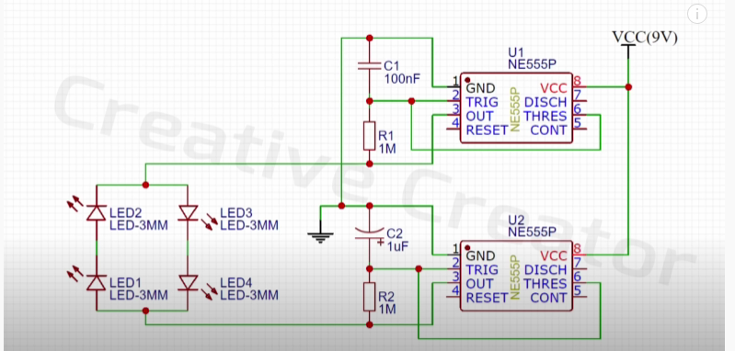

Video circuit in operation:

[](https://www.youtube.com/embed/pAakkT6LoAI?start=4&feature=oembed)

Data table for the second set of measures:

